GO TO:
education.weebly.com

• Your own educator website is free (you can have up to 10)
• Only a few of the items (like uploading song or video) are upgrades that you have to pay for
• You can have up to 40 student websites
• You can make up your own name, to start off this URL: ___________________.weebly.com OR pay more for your own domain name (like: www.phsFrench.com ).
• Weebly hosts / publishes your website for free, too

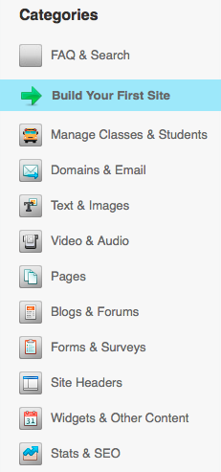
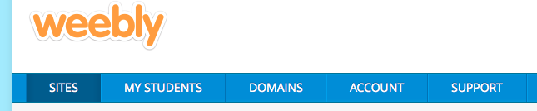
Once in the weebly website, clicking here will get you to a good tutorial menu:
There are a number of Youtube videos that are very helpful:

• This one is only 11 minutes -- very good basics youtu.be/fIMjRY7q2CA

• This one is much more in-depth -- an hour long
youtu.be/r6tZQrLJBFQ

Just be sure to remember that you want to use the educator version of weebly -- no ads, no fees
⬆

